Comprehensive Assessment: Mini Project Report
Course: CSC102-2 Data Structures (C Programming)

Arcadia: Command-Line RPG & Player Management Hub
Domain: Gaming & Simulation

Submitted To:
Dr. Manjunatha Hiremath Department of Computer Science CHRIST University

Date of Evaluation: 03-March-2026

Team Member Details
- Member 1: Suryachalam V M — Roll No: 2540146
- Member 2: Bharghav Shree Raj G — Roll No: P2540112

Problem Statement & Objective
The primary objective of this project is to architect a robust, interactive system that utilizes a comprehensive suite of data structures strictly using the C standard library.
Traditional academic implementations of data structures are often isolated and theoreti- cal. This project bridges the gap between theory and application by integrating multiple dy- namic memory structures (Linked Lists, Trees, Graphs, Priority Queues) into a single, cohesive state-machine. The core challenge addressed is managing real-time dynamic memory alloca- tion (malloc, free), ensuring data persistence via binary file handling, and executing efficient search/sort algorithms without memory leaks or segmentation faults.

Domain Description & Justification
Selected Domain: Gaming (Text-Based Role-Playing Game & Simulation)
The gaming domain was selected because it inherently demands complex, interdependent data models. A functional game engine requires:
- Spatial Navigation: Handled via Graph theory (Adjacency Lists).
- Entity Management: Handled via Binary Search Trees (Bestiary) and Linked Lists (Inventory/Quests).
- Turn-Based Logic: Handled via Circular Queues (Combat loops).
- Economy/Sorting: Handled via Priority Queues (Item Shops) and Insertion Sorts.
By mapping abstract data structures to concrete game mechanics (e.g., a Max-Heap representing an item shop sorted by rarity), the application demonstrates a profound, practical understanding of computer science principles.

In-Depth Data Structure Implementation
This section details the theoretical application and structural design of the mandatory data structures utilized in the Arcadia engine.

Doubly Linked List (Dynamic Inventory System)
Implementation: The player’s inventory is built using a dynamically allocated Doubly Linked List. Each InventoryNode contains an Item struct and two pointers: *prev and *next.
Justification: A doubly linked list was chosen over an array because an inventory size is highly dynamic. It allows for O(1) deletion time when a player consumes an item from the middle of the list, without needing to shift subsequent elements. It also permits bidirectional menu traversal.
Time Complexity: Insertion: O(1), Deletion: O(1) (given the node), Traversal: O(n).

Priority Queue / Max-Heap (Item Shop)
Implementation: The item shop is implemented as a Priority Queue backed by a contiguous array formatted as a Binary Max-Heap. The heap property is maintained using the item’s rarity integer as the sorting key.
Justification: When generating a shop, the highest rarity items must always be prioritized and presented first. Using a Max-Heap ensures that extracting the best item is mathematically guaranteed to be highly efficient.
Time Complexity: Insertion: O(log n), Extract-Max: O(log n), Peek: O(1).

Binary Search Tree (Bestiary Archives)
Implementation: Discovered enemy statistics are logged in a Binary Search Tree (BST), structured via MonsterInfo nodes with *left and *right pointers. Nodes are placed based on their unique integer ID.
Justification: A game bestiary requires rapid lookups for enemy weaknesses. By enforcing the BST property (left child < parent < right child), we bypass linear O(n) search times, significantly optimizing data retrieval.
Time Complexity: Search, Insertion, Deletion: O(log n) (average case).

Circular Queue (Combat Event Log)
Implementation: The scrolling battle text is managed by a fixed-size Circular Queue. It uses a head pointer and modulo arithmetic (head + count) % capacity to wrap around the array. Justification: An event log only needs to show the most recent N messages. A circular queue prevents memory reallocation overhead by continuously overwriting the oldest message at the tail once the capacity is reached.
Time Complexity: Enqueue: O(1), Dequeue: O(1).

Adjacency List Graph (World Map Exploration)
Implementation: The game world is a directed graph. Each Room acts as a vertex, containing an array of characters (the room name) and a singly linked list of Edge structs pointing to adjacent Room memory addresses.
Justification: A sparse graph (where rooms only connect to 1-4 other rooms) is vastly more memory-efficient when implemented as an Adjacency List rather than a 2D Adjacency Matrix, preventing the waste of unused memory allocations.

Algorithmic Complexity & Logic

Hashing & Binary File Persistence (DJB2 Variant)
To achieve persistent data, the system uses binary file operations (fread, fwrite). To avoid searching the entire database file for a username string linearly, we implemented a variant of the DJB2 hashing algorithm:
hash = ((hash << 5) + hash) + (unsigned long)c;
This converts the username string into a unique unsigned long integer, acting as a rapid identifier key for saving and loading player structs to player data.dat.

Max-Heapify Operations
When an item is added to the Priority Queue shop, pqHeapifyUp is called. It compares the newly inserted child at index i with its parent at index ⌊(i−1)/2⌋. If the child’s rarity is greater, they swap. This continues iteratively until the Max-Heap property is restored. Extraction uses pqHeapifyDown, swapping the root with the largest of its children at 2i + 1 or 2i + 2.

Sorting (Insertion Sort)
The system employs an in-place Insertion Sort to organize the player’s inventory by item value.
    - Algorithm: The algorithm iterates through the data, growing a sorted partition behind the current element. It checks the current item against previous items, shifting them right until the correct value-hierarchy position is found.
    - Complexity: O(n²) worst-case, but highly efficient (O(n)) for small datasets like a player inventory, with O(1) auxiliary space.

Searching (Binary & Linear)
    - Binary Search: Deployed on the Leaderboard array. By calculating mid = low + (high
- low) / 2, the algorithm eliminates half the search space per iteration, finding a specific player level in O(log n) time.
    - Linear Search: Deployed in the Inventory using C’s strstr() to allow partial-string matching. It iterates from the head node to the tail node, operating in O(n) time.

Sample Output Demonstration
- Memory-Safe Main Menu & Graph Traversal
+ +
|Arcadia Command Nexus |
|Adventurer: Surya | HP 100/100 | Gold 125 | Level 1 |
|Inventory 3 items | Quests 2 | Realms 4 | Location: Sunlit Entrance |
+ +
> 4 (Explore World)
+ +
|You stand in Sunlit Entrance. |
| Exits: E N |
+ +
Choose direction (N/S/E/W) or B to return: N You travel N into Forgemaster Armory.

- Max-Heap Extraction & BST Lookup
+ +
|Item Shop [Priority Queue / Max-Heap]
| Void Crystal | Value 200 | Rarity 5
| Mana Shard | Value 80 | Rarity 3
|
|
|
+ +
> 2
Purchased: Void Crystal (Value 200, Rarity 5).
> 6 (Bestiary)
Enter monster ID: 220
ID 220 | Stone Golem | Weakness: Lightning
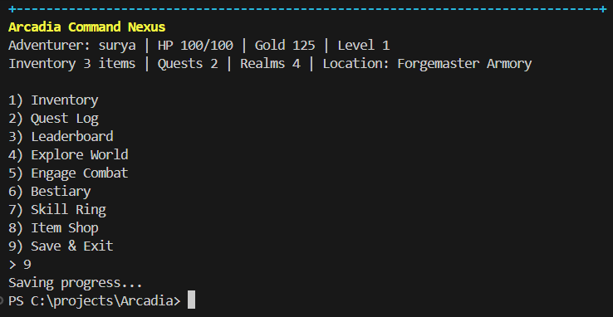
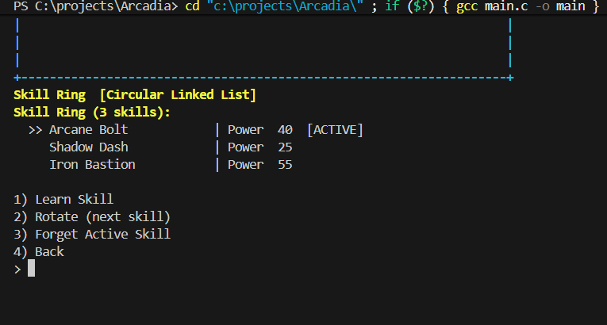

Source Code & Repository
The complete, compilable C source code for the Arcadia RPG, including all header files, data structure implementations, and version history, is hosted publicly on GitHub. Evaluators can review the raw codebase and modular structure at the following link:
GitHub Repository: https://github.com/sgk18/Arcadia

Conclusion
The Arcadia RPG successfully demonstrates that complex data structures are not just abstract concepts, but the foundational building blocks of interactive software. The application strictly adheres to C language standards, utilizes robust memory management practices (explicit malloc and free architecture) to prevent memory leaks, and demonstrates theoretical computer science algorithms through practical, gamified execution.

